**Why do Social Media Marketing ?**

In the past, advertising campaigns were limited to radio, TV, and print ads. However, as time passed, marketing trends changed as well.

With almost all consumers using social media nowadays, it's essential for every business to have a very structured and active social media presence. Social media has a big influence on a consumer's purchasing decisions these days. The better the brand's social media presence, the more consumers trust them. Therefore, it is essential for every business to ensure that its social media presence is well-structured and active.

**What exactly is social media marketing, then?**

Social media marketing is the process of connecting with and communicating with potential customers in order to ultimately increase sales and brand awareness. Us Misc Archive is one of the best digital marketing agency in Trivandrum you can find to elevate your sales as well as brand awareness through social media marketing.

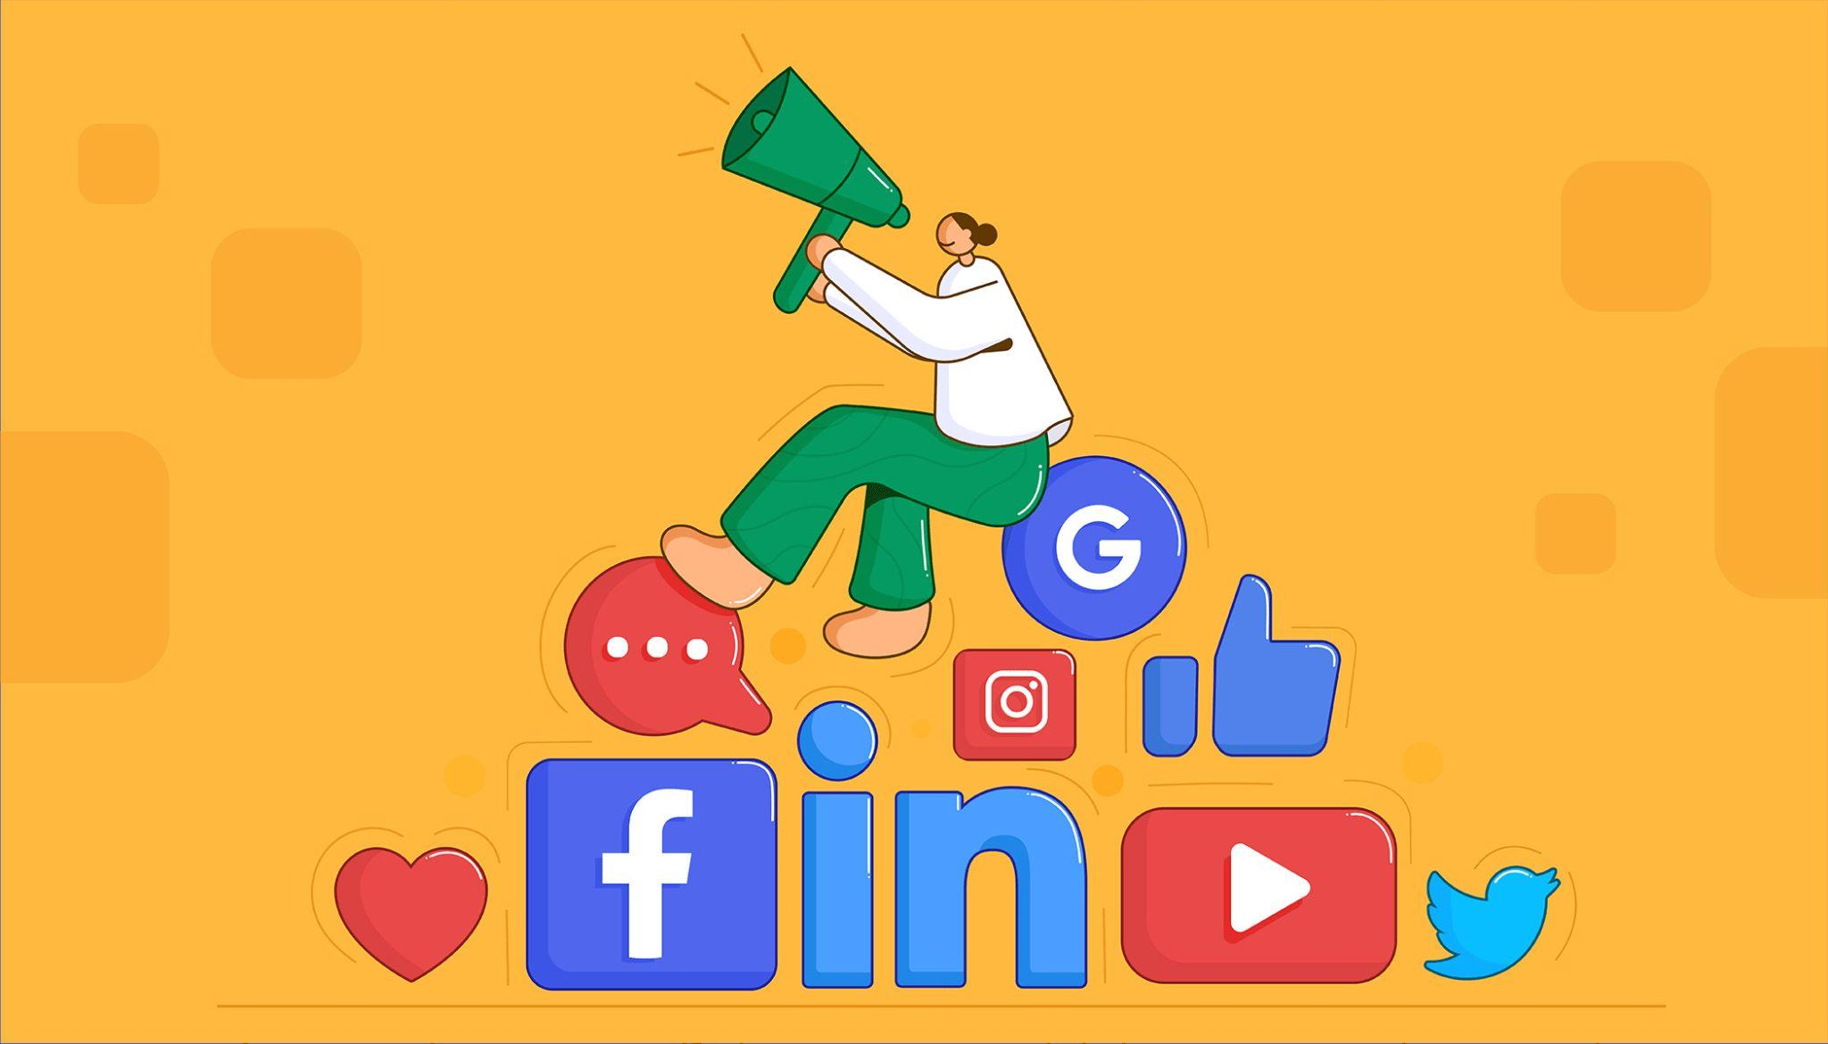

**Why is social media marketing necessary?**

With the ability to reach a larger audience, social media platforms have become an essential tool for many brands. Businesses may engage with their audience through social media channels to:

* Build a brand.
* Increase brand awareness
* Increase sales.
* Drive traffic to your website.
* Build a community of followers to share and engage with your brand.

**What do we do to help your brand take control of Social Media?**

**1. Social Strategy**

Just like anything, Social media marketing requires a strategy as a vital component. Recognizing your audience's demands, how they relate to your aims, and how you may attract them with an offer that encourages them to support your company are all necessary.

**2 Create and Curate content**

“Content is King” - Bill Gates

Creating fresh content is very important when coming to Social Media. Content creation is the idea of creating topic ideas that can be posted on social media platforms. Those which can eventually help the brand build awareness or convert a probable customer. It can help us from getting the attention of our prospective buyers or consumers to build trust.

**3 Listening and engagement**

Today, a company's reputation may make or break them. Customers can quickly promote your goodwill on social media or call you the worst ever. Knowing what others are saying about you on social media helps you to react effectively and, if necessary, do the needed damage control.

**4 Analytics and reporting**

Finding and Collecting data can help us take business decisions and measure the performance of our social media activities. Tracking and analyzing data from social networks such as Facebook, Twitter, Instagram etc can help the business optimise marketing strategies

**5 Advertising**

Social Media Ads are basically paid Ads that can be given to boost our Brand presence or Introduce products. Social media ads can be used to deliver customised content to their audiences and hyper-target them based on demographics, user behaviour and Interests. Additionally affordable, social media advertisements provide an excellent return on investments, Making it one of the most used and conventional ways of marketing.

**Why choose Misc Archive?**

We are a growing digital agency with experienced and energetic marketing professionals always ready to help you digitally grow your brand, thereby gaining traction and growing your business. Our digital marketing services include Social Media Marketing, Marketing Automation, PPC, Video production, SEO, email marketing, and more. We strive to provide our clients with the best solutions and strategies that will help them reach their goals quickly. Making Misc Archive is indeed the best digital marketing agency for you. We are the perfect choice for all of your digital marketing needs. So what are you waiting for ?

**Contact us NOW** !!